Mise-en-Scène

What is Mise-en-Scène?
- A French term meaning what is put into a scene or frame
- Visual information in front of the camera
- Communicates essential information to the audience
- made up of various elements

Elements of Mise-en-Scène?
- Settings & Props
- Costume, Hair & Make Up
- Facial Expressions & Body Language
- Lighting and Colour
- Positioning of characters/objects within the frame

The following research activities will help familiarise you with the concept and develop image interpretational and analytical skills.

Consider the questions below to provide a framework for your blog and a brief summary of what you have learnt.

Research Activity 1

Can you describe how the elements of Mise-en-Scène in the following scene?

Watch the following scene

- Snow White (Disney Studios,1937)
- https://www.youtube.com/watch?v=cB7O_JIxGuY

- Settings & Props
The first scene features an apple, a cauldron filled with potion, and an environment resembling a dim basement, along with a witch and her raven. The second scene takes place in a forest cabin, where Snow White, a fruit pie, and small animals like deer and birds are present. After the witch appears, two vultures are added to the trees.
- Costume, Hair & Make Up
The witch wears a black cloak and constantly keeps her hood up. She has white hair and a long nose with a wart. Her irises are tiny, accompanied by heavy dark circles under her eyes. Her eyebrows are perpetually arched, and she has only a few scattered teeth in her mouth. Her overall silhouette resembles that of a vulture.

Snow White is dressed in more vibrant clothing, with the red and blue hues on her outfit having higher saturation compared to the surrounding environment. The hair bow on her head, the color of her lips, and the red accents on her shoulders all coordinate with one another.
- Facial Expressions & Body Language
The witch's eyes are particularly striking. Compared to Snow White's, her eyes are abnormally large and dominated by the whites, creating an eerie and unsettling impression for the audience. She stares fixedly at other characters, such as the raven and Snow White. Her eyebrows are perpetually arched and set very close to her eyes—a design that typically conveys sternness or menace, which starkly contrasts with her smile. This facial expression makes her smile appear artificial and unsettling.
- Lighting and Colour
The opening scene is shrouded in lingering white mist, creating a mysterious atmosphere. Both the green potion and the red apple appear ominous, evoking a sense of danger. The witch's basement, along with the raven inside, is predominantly draped in dark tones, contributing to an overall oppressively somber mood. In contrast, Snow White's dwelling is rendered in warmer and softer tones—until the witch appears and casts a shadow, causing the interior lighting to become even gloomier than the world outside.
- Positioning of characters/objects within the frame
The witch dominates in many shots. In her single shots, she occupies most of the frame, and even in the shot by Snow White's window, she is positioned at the center of the composition. This creates a stark contrast with Snow White's single shots, where she is often placed slightly to the left of the frame. In two-shots, the witch almost forces the raven and Snow White into the corner of the frame. I also particularly like the shot where she first appears by the window—it feels as though she breaks the fourth wall, staring directly at the audience. These shots effectively convey the witch's menacing presence.
- What role does the shot choice (Cinematography) play in the scene.
When the witch hands the apple to the raven and threatens it, the camera zooms in, creating the effect for the audience as if the apple is abruptly pushed right before their eyes. The shot where the witch appears outside Snow White's window also leaves a deep impression on me—it's a hard cut. Right after seeing the shadow in the previous shot, the audience immediately sees the witch, combined with her expression and her body dominating most of the frame. These shots vividly convey the witch's aggressiveness and threatening nature.

Research Activity 2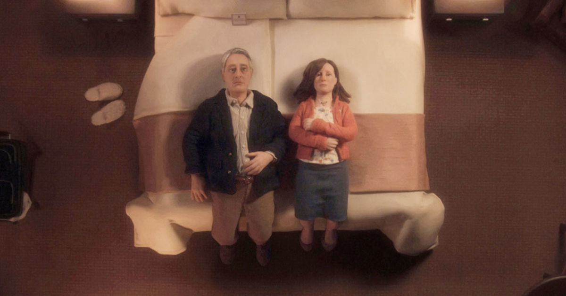
Anomalisa. Charlie Kaufman 2016
Can you describe the mise-en-scene in this picture? How are the characters placed in the frame?

In this frame, there is a large double bed with what appears to be a pair of disposable slippers beside it. Two nightstands are positioned on either side of the bed, while a clothes rack with garments stands on the left side—though these elements do not dominate the composition. The overall lighting in the scene is rather dim, evoking the ambiance of a warm bedroom. A card rests on the bed, accompanied by neatly arranged bedding, though I'm uncertain whether this layout corresponds to a hotel room.
Two characters, fully dressed, lie side by side on the bed with their legs still hanging off the edge—likely having sat down first before leaning back. Their expressions appear weary or numb, creating a stark contrast with the cozy atmosphere. The woman has her arms crossed over her chest, a posture that often suggests resistance or emotional distance, while the man's posture is similarly restrained.
The composition is highly symmetrical, with the seam of the bedspread visually emphasizing this balance. That said, if one looks closely, the man's body and his dark clothing draw more visual weight, subtly breaking the central axis of the frame.

Research Activity 3

Watch this scene from Rebecca.
https://www.youtube.com/watch?v=h23zAV2Wnps
(36mins into the film)

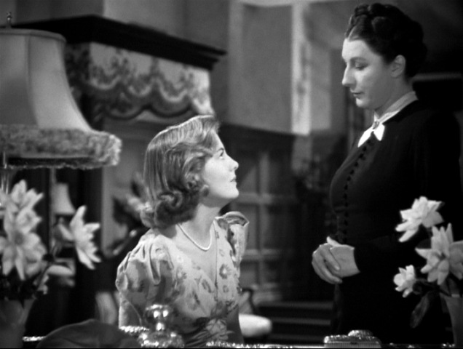
Rebecca (Hitchcock.1940)

Can you describe the relationship between the characters?

How do we know what the relationship is?
Can you describe how the mise-en-scene works together to tell us what the relationship is?

Based on the scene where the two characters appear, the overall setting is very opulent. The female protagonist is seated at a desk, on which three notebooks are neatly arranged. To the left of the desk, there is a telephone, flanked by ornate candlesticks on both sides. These candlesticks are exceptionally tall, framing the heroine within the composition as she sits.
From their attire, I infer that the relationship between the two characters is that of a new mistress and a long-serving housekeeper. The character on the right is dressed in a black, classical, and relatively plain outfit, appearing more stern compared to the character on the left. The latter is dressed in more fashionable clothing, with meticulously styled curly hair.
In terms of composition, the housekeeper on the right stands upright, gazing down at the seated mistress on the left without lowering her head. The mistress, in contrast, looks up at her, her body slightly curled, creating a visual impression of the housekeeper scrutinizing the mistress. Although the mistress occupies most of the frame, the housekeeper's posture and demeanor convey a stronger presence.
Additionally, the mistress's flustered movements and somewhat unpolished actions in her lines and performance suggest that she is likely new to the estate. The housekeeper, on the other hand, calmly explains the use of the telephone, indicating that she has likely been working there for a long time.

High Key Lighting
Low Key Lighting

Natural Lighting

High Angle Shot

Low Angle Shot

Can you describe the mise-en-scene in this picture?

What type of shot is it?
What is the camera angle?
Where is the character located in the frame?
What is she wearing?
What is the depth-of-field?
Describe the colour palette?
Describe the lighting?

WhWhat

W

